DOKUZ EYLUL UNIVERSITY
ENGINEERING FACULTY
DEPARTMENT OF COMPUTER ENGINEERING

CME1251 PROJECT BASED LEARNING – I
FINAL REPORT
PROJECT – III

CENGERS

by
Fatma Ceren Akyüz
Tuğrul Demirözer
Bedirhan Karaahmetli

Lecturers
Assoc. Dr. Derya Birant
Dr. Meltem Yıldırım

07.01.2021

CHAPTER ONE
PROGRESS DESCRIPTION
In the first week of our project, we discussed what was asked of us and what we could do in return. Instead of working on the code piece by piece, we decided to write together on a single code. When we first started the code we created the required static variables and created an 8x8 two dimensional array to use anywhere in the main function.
In the main procedure, we printed the game table and array elements which are ‘.’ for gaps and game stones which are ‘O’ and ‘X’. Also, we printed the turn steps, which shows whose turn it is in the game, and the round variable, which shows which round the game is in. Then we opened a procedure and we arranged the cursor position, controlled the player’s step movements and controlled the pressed keys. Then we opened another procedure and we controlled the computer’s step operations in it.
After all these processes, we coded the single jump steps for the computer and the player and checked whether this was a successful jump.
Finally, we designed the algorith for double jump operation for both the computer and the player and we put it into code. We’ve added some changes to beautify our code and make it more readable and we’ve finished all the rest.

CHAPTER TWO
TASK SUMMARY

Completed Tasks
Creating the necessary variables and printing the screen is complete.
For the player:
• Arrow keys control provided.
• Control of the place where the stone to be moved is selected and moved is provided.
• Control and execution of one-step movement and successful jumping operations were provided.
For computer:
• The step operation has been completed.
• Control and execution of single and double jump operations was ensured.

Additional Improvements to the Project
Everything requested from us in the project has been successfully achieved. Checks done. No extra feature has been added.

CHAPTER THREE
EXPLANATION of algorıthms

Screenshots
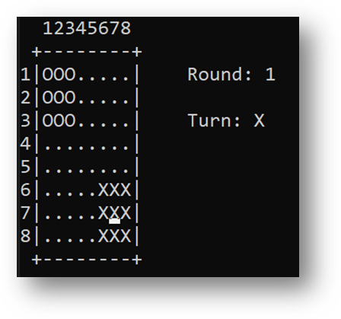
Figure 3.1.1 Starting the game

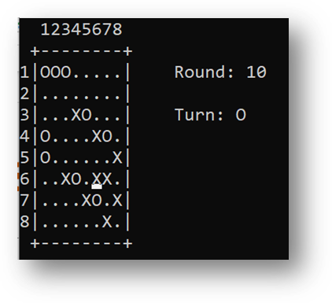
Figure 3.1.2 In game screenshot

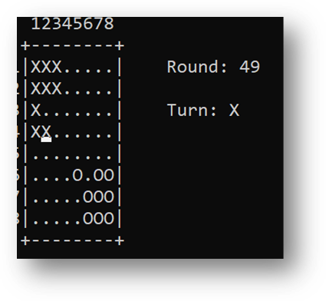
Figure 3.1.3 In game screenshot

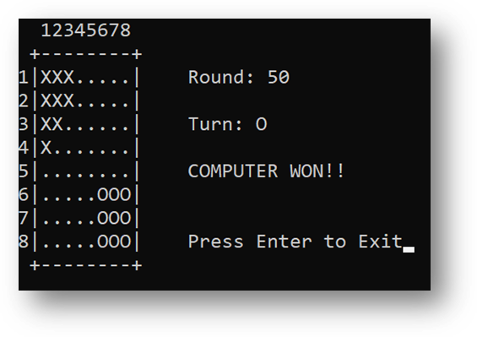
Figure 3.1.4 Computer won screen

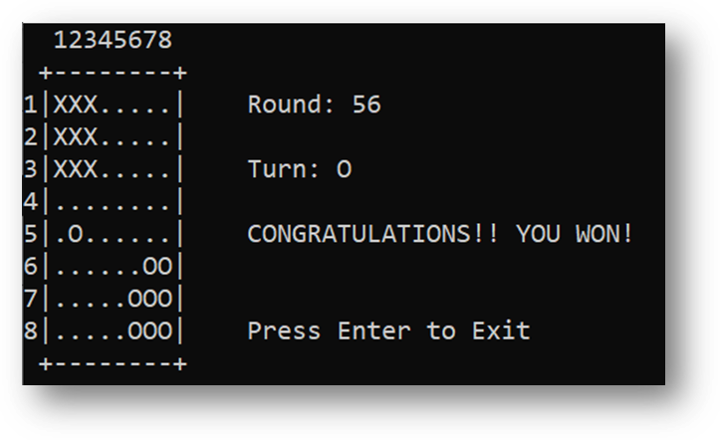
Figure 3.1.5 Human won screen

Functions
Controls function created for player moves.
AIControl function created for computer.
ReverseControl function created for prevent the computer from stucking.
WinChecker function created for check the winner.

Algorithms and Solution Strategies
• Two-dimensional arrays for the game board; x and y-axis of the computer’s pieces, the maximum number of moves they can do, and temporary locations.
• Functions for the control of human movements, the endgame winner, the AI control and reverse control.
• ReadKey command to move the cursor.
• SetCursorPosition command to determine the location of the cursor.
• An infinite while loop to keep the game running.
• Switch cases for cursor movements.
• Boolean variables for functions and loops.
• Nested for loops for arrays.
• Environment.Exit command to leave the game.

Flowcharts
We wrote a static void procedure for player’s step operations.
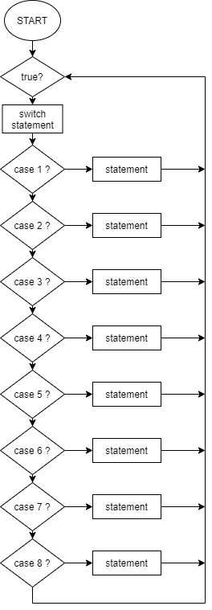
Figure 3.4.1 Flowchart.1

We created an infinite while loop and created switch cases to control the press key in it. If the pressed key is one of the arrows then the cursor moves the printed arrow’s way. If the pressed key is esc then the game stops. If the pressed key is Z and the cursor is on X, then this X stone is chosen for playing. If the pressed key is X, the cursor is at the ‘.’ and there is an X ​​to the left or right of the cursor, the selected stone moves to the cursor's location. If there are no moves left, the user presses the C key and the game switches to the computer. After each key pressed, the code exits the switch case and returns to the beginning of the while loop. (Figure 1.2 example flowchart)

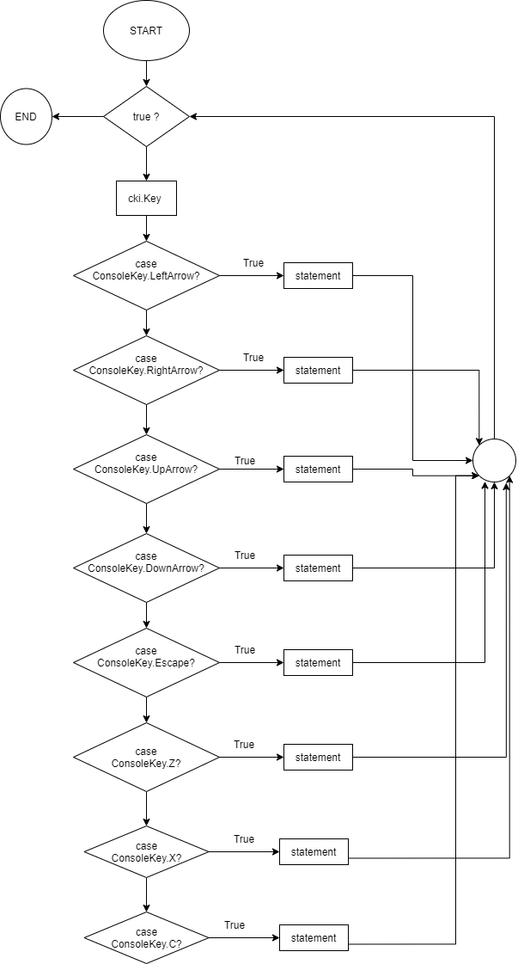
Figure 3.4.2 Flowchart.2

We used nested for loops to assign the '.', 'O', 'X' elements in the game table to the elements of the array and print the game table. (Figure 1.3 Example flowchart)
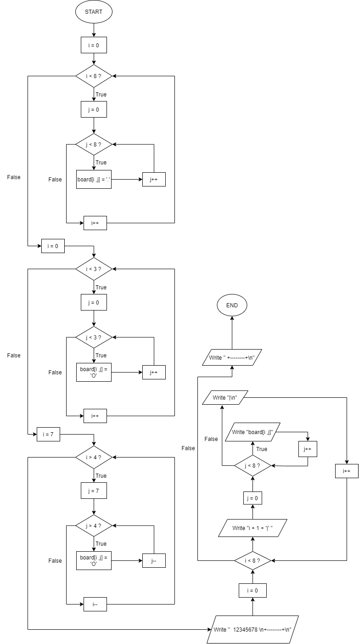
Figure 3.4.3 Flowchart.3

We assigned the cursor position and created an infinite while loop. In this loop we showed whose turn it is in every movement and in every two steps we increased the round one by one. (Figure 1.4 Example flowchart)
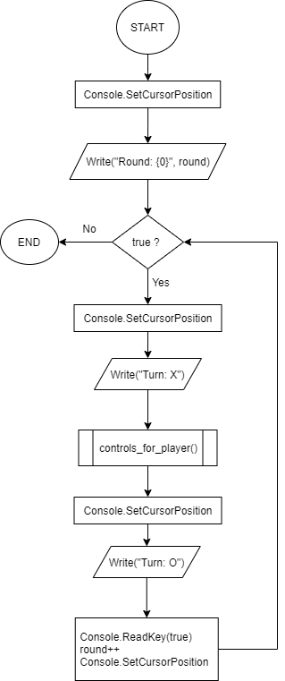
Figure 3.4.4 Flowchart.4

CHAPTER FOUR
PROBLEMS ENCOUNTERED
When it was the turn of the computer and there were no moves to the right or down, the pieces were getting stuck. We solved it by using ReverseControl function.
The pieces of the computer were not collecting in the 3x3 area. We solved it by using ReverseControl function.
Player could make multiple pieces jump during their turn.
Player could move piece diagonally.

CHAPTER FIVE
conclusıon
Thanks to this project, we learned to write çözde and schedule management in cooperation. We developed our skills in this field by working on two-dimensional arrays. We have also stepped into the field of artificial intelligence by making a small-scale artificial intelligence software. Thanks to this project, we have madem new beautiful friendships.

REFERENCES
- https://docs.microsoft.com/tr-tr/dotnet/api/system.environment.exit?view=net-6.0
- https://docs.microsoft.com/tr-tr/cpp/c-language/recursive-functions?view=msvc-170

AppendIx A
Poster of the Project
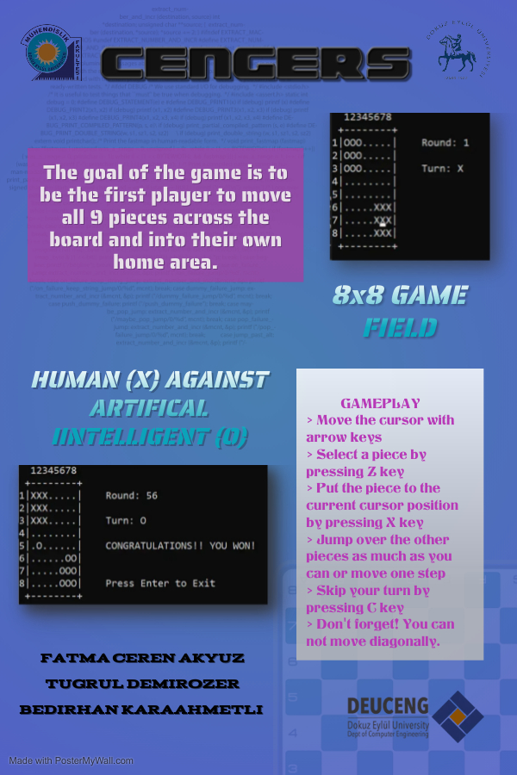
AppendIx B
Code of the Project
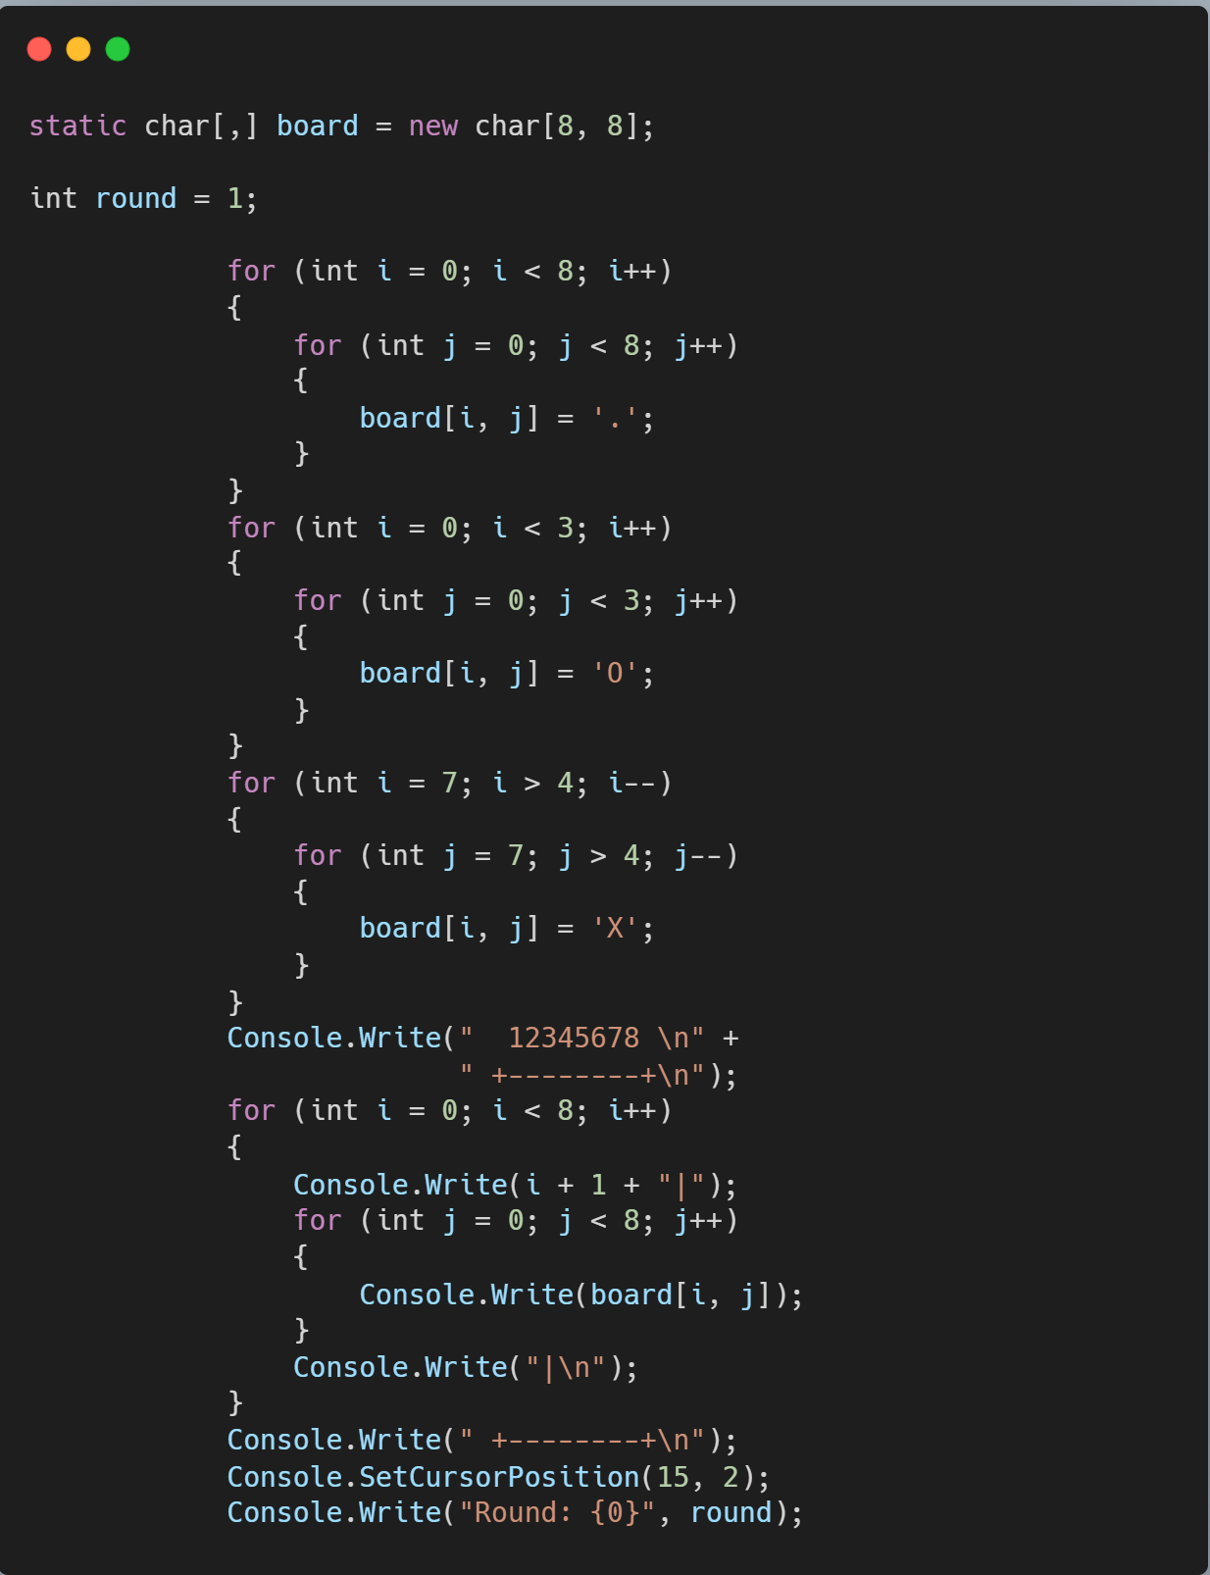
Figure 5.1 Printing Screen

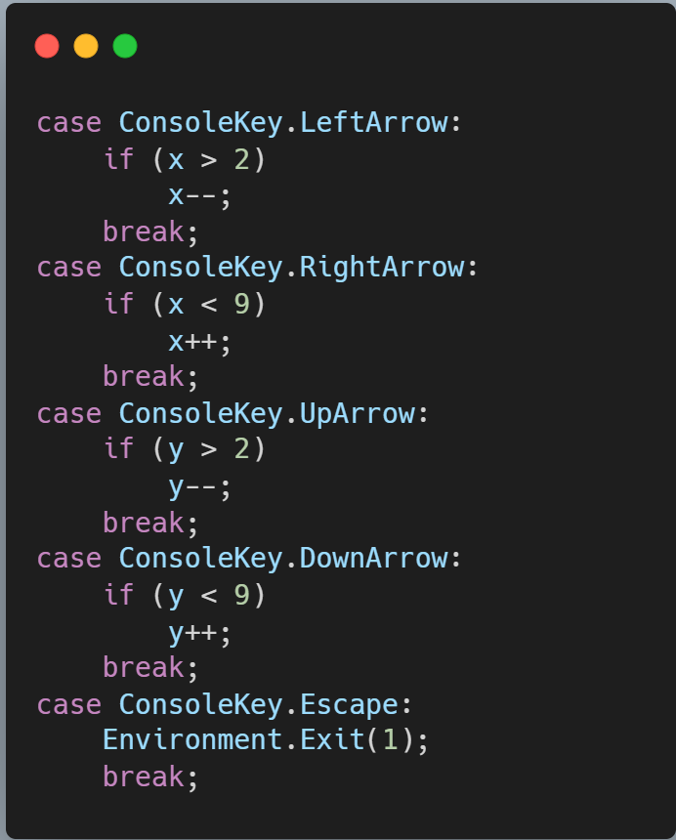
Figure 5.2 Cursor movement and quiting game

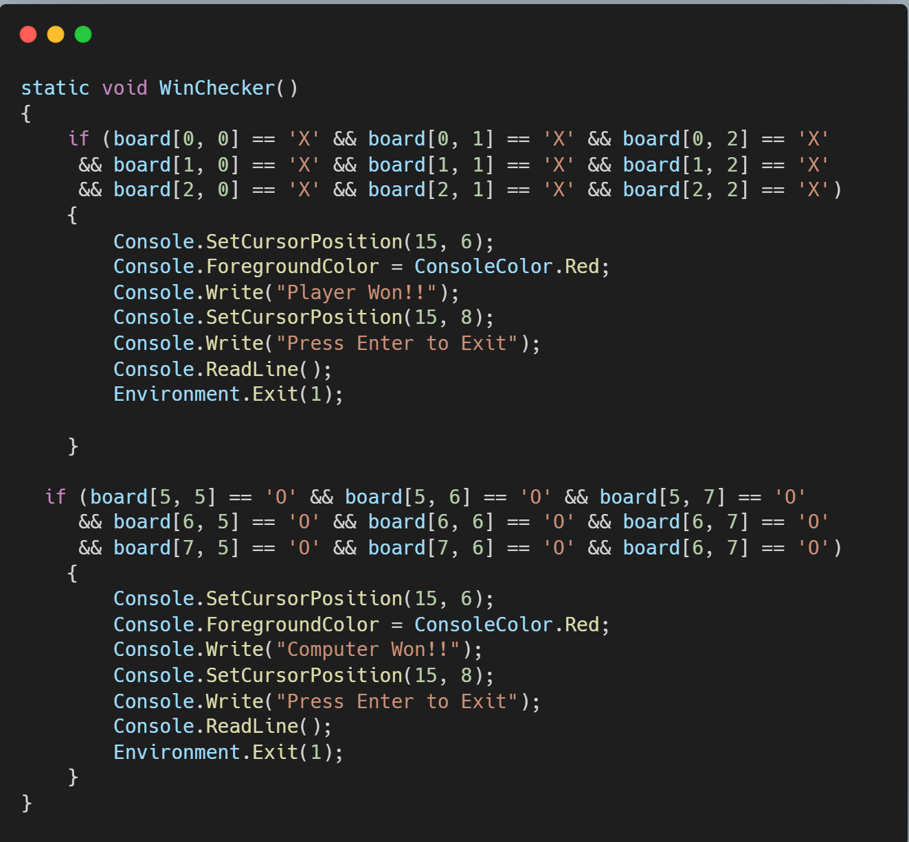
Figure 5.3 Checking winners

